HEALTH & HUMAN DEVELOPMENT

UNIT 4 OUTCOME 1

Introducing Global Health & Human Development

Analyse factors contributing to variations in health status between Australia and developing countries.

Name ______________________________

Instructions:

There is one section to this paper.
Total marks available: 34 marks

Reading time: 10 minutes
Writing time: 60 minutes

You are required to answer each of the questions in the booklet provided.
Materials permitted: pens, pencils, highlighters & erasers.
There are to be no mobile phones in the classroom during the SAC.

Question 1
Define the following terms.
- Human Development
______________________________________________________________
______________________________________________________________
______________________________________________________________
______________________________________________________________
______________________________________________________________
______________________________________________________________
Sustainability
______________________________________________________________
______________________________________________________________
______________________________________________________________
______________________________________________________________
______________________________________________________________
______________________________________________________________
- Briefly explain what is meant by each of the following terms in relation to
sustainability.
Equity
____________________________________________________________________
____________________________________________________________________________________________________________________________
Affordability
______________________________________________________________
____________________________________________________________________________________________________________________________
2+2+2 = 6 marks
Question 2
Lithuania, a country in Europe, has low child mortality and high adult mortality according to the World Health Organisation.
- Identify the strata that Lithuania would be classified as in the mortality strata system.

1 mark

- Explain how these levels of mortality may impact on the level of human development experienced in Lithuania.
__________________________________________________________
____________________________________________________________________________________________________________________
__________________________________________________________
____________________________________________________________________________________________________________________
3 marks

Question 3
Table 1: Sixteen (16) highest ranked causes of YLL (Years of Life Lost) in 2010 for Australia and the Central African Republic expressed as a percentage of total deaths.
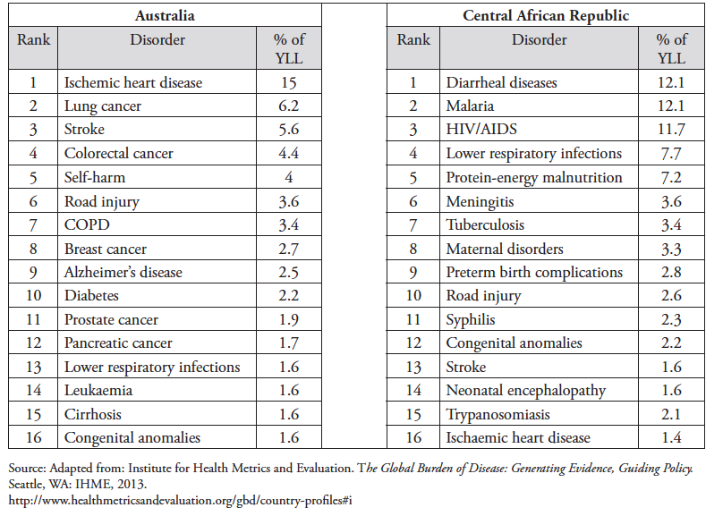
a. Identify one similarity and one difference in the YLL between the Central African Republic and Australia represented in the table.
Similarity:
______________________________________________________________
______________________________________________________________
______________________________________________________________

Difference:
______________________________________________________________
______________________________________________________________
______________________________________________________________
2 marks
Table 2: Key indicators – Australia and Central African Republic
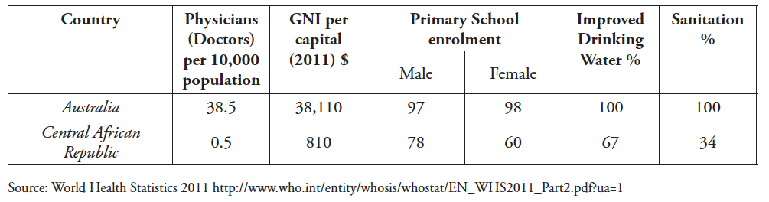

b. Select three key indicators from Table 2 and discuss how each one might account for the differences in the YLL between Australia and the Central African Republic as shown in Table 1.

Key Indicator Selected:
______________________________________________________________
How it might account for the differences in YLL:
______________________________________________________________
______________________________________________________________
______________________________________________________________
______________________________________________________________
______________________________________________________________

Key Indicator Selected:
______________________________________________________________

How it might account for the differences in YLL:
______________________________________________________________
______________________________________________________________
______________________________________________________________
______________________________________________________________
______________________________________________________________
Key Indicator Selected:
______________________________________________________________
How it might account for the differences in YLL:
______________________________________________________________
______________________________________________________________
______________________________________________________________
______________________________________________________________
______________________________________________________________
6 marks
Question 5
Table 3 (over the page) shows the leading 25 causes of DALYs (Disability Adjusted Life Years) in Indonesia and the percentage change between 1990 and 2010. Use the information in Table 3 to answer the following questions.

a. Identify the leading cause of DALYs that showed the largest increase between 1990 and 2010.
______________________________________________________________
______________________________________________________________
1 mark
b. Discuss how global marketing might have influenced the changes in health status in Indonesia between 1990 and 2010.
______________________________________________________________
______________________________________________________________
______________________________________________________________
______________________________________________________________
______________________________________________________________
______________________________________________________________
______________________________________________________________
______________________________________________________________
3 marks
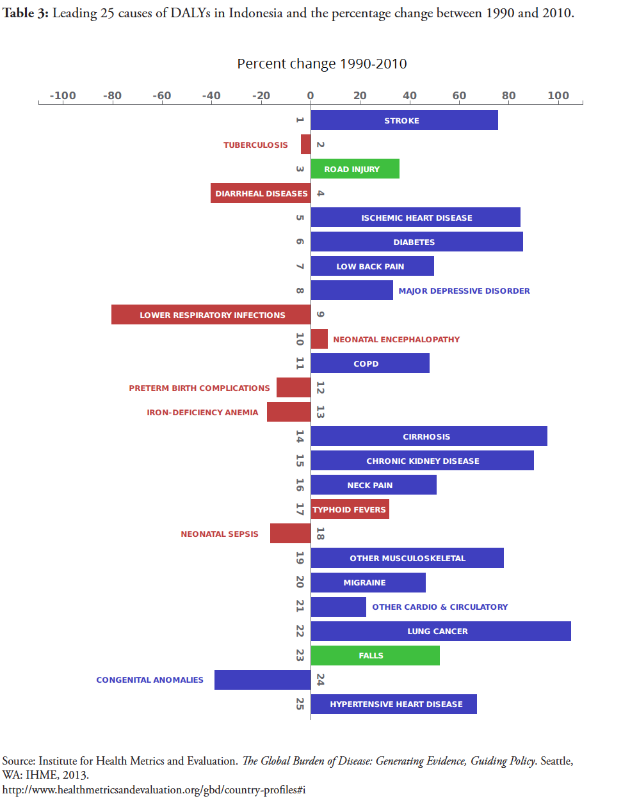
Question 6
The following graph shows the Human Development Index (HDI) for selected countries over time.

- Explain the Human Development Index.
__________________________________________________________
____________________________________________________________________________________________________________________
__________________________________________________________
2 marks
- Outline the changes in the Human Development Index as experienced in Australia and the DRC between 1980 and 2012.
__________________________________________________________
____________________________________________________________________________________________________________________
__________________________________________________________ 2 marks

Question 7
The following graph shows the U5MR and infant mortality rates for selected countries. ‘Infant mortality’ relates to deaths in the first year of life.
 | Under 5 mortality rate (per 1000 live births) | Infant mortality rate (per 1000 live births)
Australia | 5 | 4
Angola | 164 | 100
Mali | 128 | 80
Pakistan | 86 | 69
Ghana | 72 | 49
- Explain how peace and / or political stability may contribute to the difference in
under 5 mortality rates between Australia and one developing country as shown in the table.

______________________________________________________________________________________________________________________________________________________________________________
__________________________________________________________
____________________________________________________________________________________________________________________
2 marks
- Explain how education may contribute to the difference in infant mortality rates
between Australia and one developing country as shown in the table.
____________________________________________________________________________________________________________________
____________________________________________________________________________________________________________________
____________________________________________________________________________________________________________________
2 marks

- Besides education and peace /political stability, discuss two characteristics often associated with countries with high under 5 mortality rates.
____________________________________________________________________________________________________________________
____________________________________________________________________________________________________________________
____________________________________________________________________________________________________________________
____________________________________________________________________________________________________________________
4 marks

